Embargoed until 3 February 2026, 10:00 a.m. CET

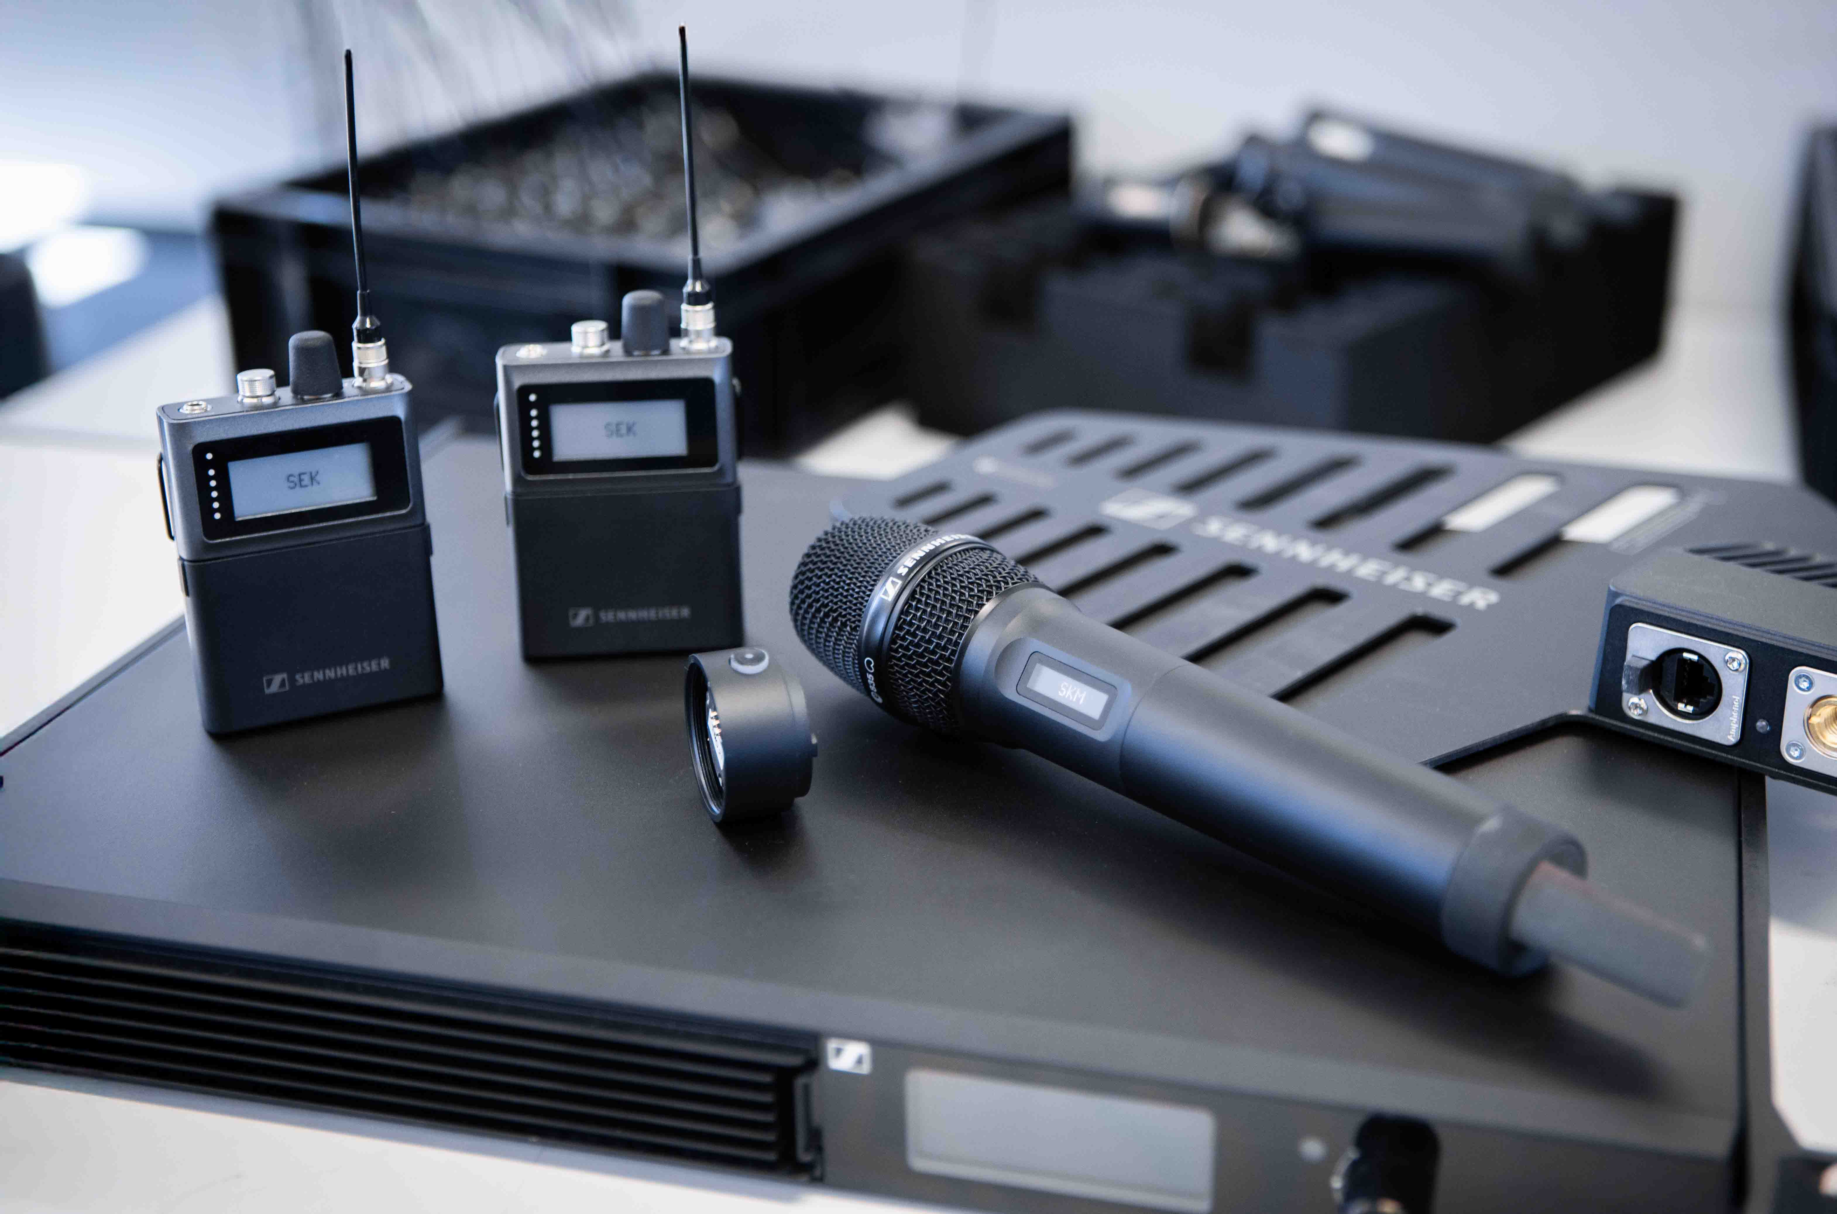 Spectera Lab at ISE 2026
Explore the possibilities that Spectera API offers – Preorder start for the Spectera handheld

Wedemark/Barcelona, 3 February 2026 – While Sennheiser’s Spectera bidirectional wideband wireless ecosystem continues to transform productions around the globe, ISE 2026 marks the preorder start for the upcoming Spectera SKM handheld transmitter (both the UHF and 1.4 GHz version) as well as for the Command adapter, which equips the handheld with a programmable Command function. Both items are scheduled to launch in September. Another highlight is the Spectera API (Application Programming Interface). Coming in Q2, it enables advanced customization and control across multi-vendor workflows. And there is more to find out in the Spectera Lab…

Regular hardware, software and functionality updates – Spectera is being continuously expanded, and the Spectera Lab (www.sennheiser.com/spectera-lab) is the place to go to receive the latest outlook on what is coming next for Spectera, and to join the co-creation of the ecosystem via the Idea Space and a Discord channel. At ISE itself, visitors will have the opportunity to directly leave their ideas for Spectera on a big touchscreen.

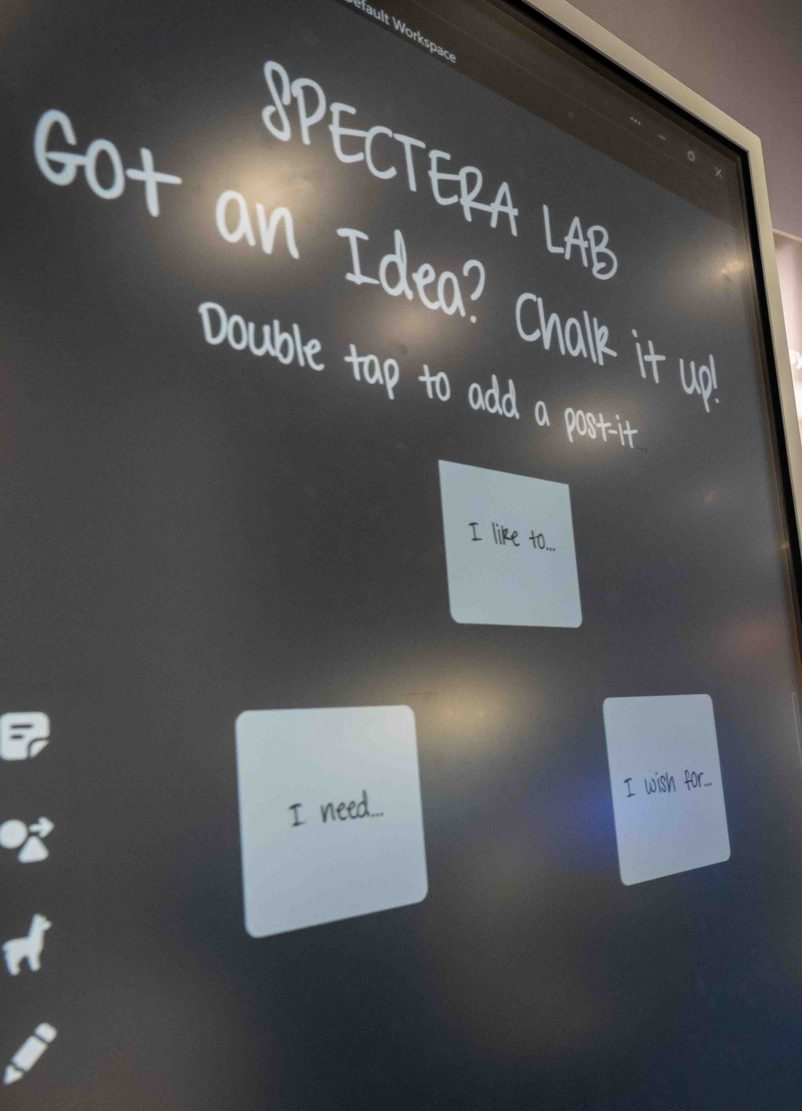 | The Idea Space taken into the physical world: ISE visitors can leave notes on their feature requests for the Spectera wideband wireless ecosystem

Much expected: the handheld
The handheld with Sennheiser standard capsule interface for Sennheiser and Neumann microphone heads features a sleek, aluminium-anodised body with OLED display. The bidirectional data stream enabled by Sennheiser’s WMAS implementation gives the operator full remote control of mic parameters such as low-cut or gain.

Prototypes of the Spectera handheld transmitter with and without programmable Command adapter | 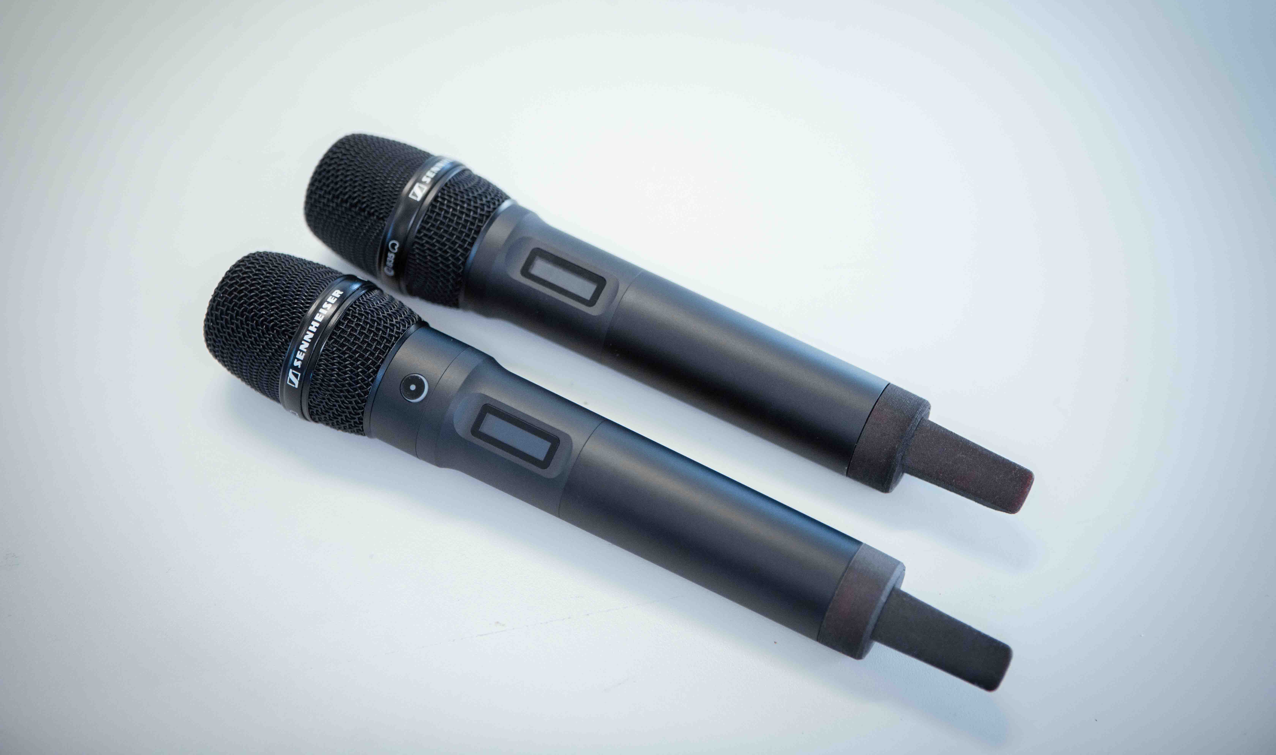

The Command adapter allows users to change the audio routing at the push of a button, for example for convenient communication between the talent and the technical crew. Whether programmed for toggling, muting, or push-to-talk, the Command functionality makes communication control easy and immediate.

Preorders for the handheld and the Command adapter are accepted from show start on 3 February.

Modular design: Spectera handheld with the standard Sennheiser capsule interface and Command adapter | 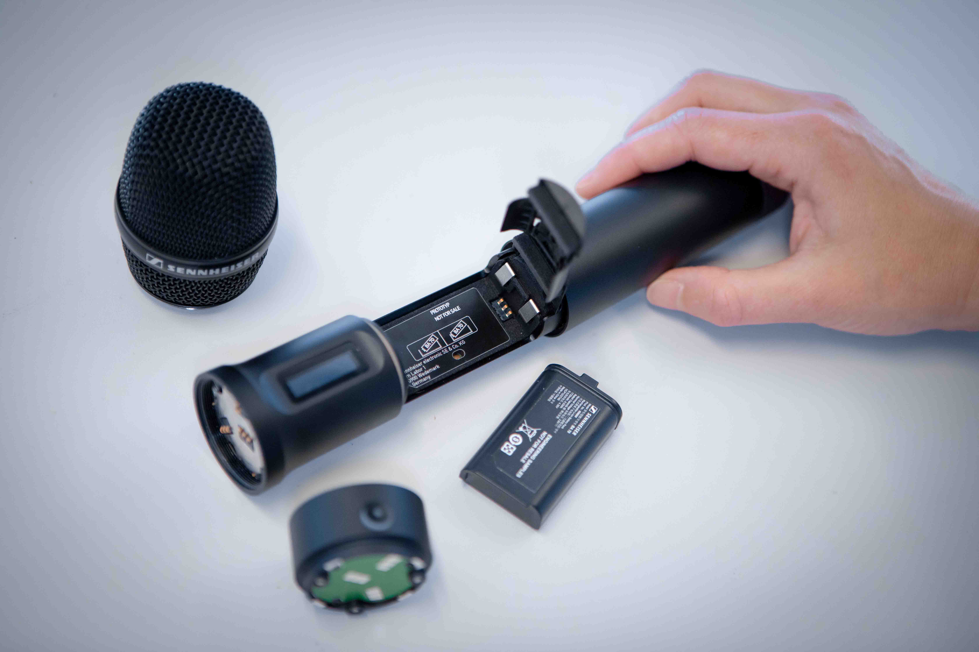

Spectera API
On a large Live Sound and Theatre display, the Sennheiser team show how the Spectera API helps customise and control the ecosystem in multi-vendor live audio workflows. Coming in Q2 and building on Sennheiser’s tradition of open protocols, Spectera API’s bidirectional capabilities unlock an entirely new level of integration, empowering productions to tailor Spectera to their precise workflow requirements – supporting both DIY users and third-party solutions from industry partners such as Bitfocus Companion, SoundBase, Sonoros, and more.

More to come
Sneak peeks of the Engineer Mode (cue mode) for live sound applications (scheduled for December 2026), the Command adapter for the SEK (scheduled for May 2026) and the Base Station ZMAN with ST 2110-30 standard for integration into broadcast workflows (scheduled for August 2026) round off the Spectera Lab showcases. The team on site are happy to give ISE visitors a deep dive and show them how Spectera’s wideband transmission can enhance their audio projects and speed up workflows.

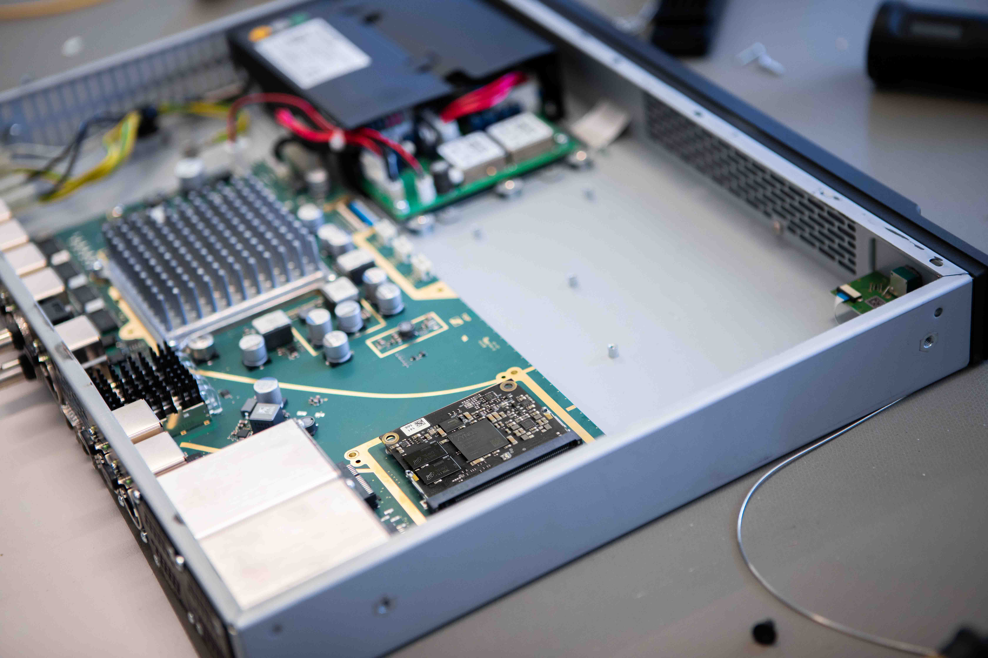 | Integration of Spectera into broadcast production workflows will be facilitated by a Merging ZMAN module, which will make the Base Station work according to ST 2110-30

Visit Sennheiser at ISE, Hall 3, stands 3B500 and 3B700.

(Ends)

The high-resolution images accompanying this media release can be downloaded here.

About the Sennheiser brand
We live and breathe audio. We are driven by the passion to create audio solutions that make a difference. Building the future of audio and bringing remarkable sound experiences to our customers – this is what the Sennheiser brand has represented for 80 years. While professional audio solutions such as microphones, meeting solutions, streaming technologies and monitoring systems are part of the business of Sennheiser electronic SE & Co. KG, the business with consumer devices such as headphones, soundbars and speech-enhanced hearables is operated by Sonova Holding AG under the license of Sennheiser.

www.sennheiser.com
www.sennheiser-hearing.com

Global Pro Audio Press Contact
Stephanie Schmidt
stephanie.schmidt@sennheiser.com
+49 (5130) 600 – 1275

